Enigma Remote user guide

Table of Contents
Background 1
Functions and features 2
User interface 4

Background
On todays market several different TV boxes are available and some of these boxes are built on the Enigma2 software system. One of these boxes, the DM800HD SE, is made by the German company Dream Multimedia just to mention one of many. Inside the Enigma2 software a plugin can be loaded that allows for external management. This makes it possible to use an iPhone to remotely control the box, such as showing and zapping between bouquets, channels and EPGs to mention some examples. The Enigma Remote is an app for iOS that has these features.
Features that have been implemented in Enigma Remote are:
- Runs on iPod and iPhone with iOS7
- Turn the box on/off (standby)
- Show bouquets and channels
- Fast zap between channels
- Show EPG for any channel or the channel currently on display
- Show information about the TV box

Functions and features
The primary goal of Enigma Remote is to easily zap between the available channels in the TV box. To control the box an interface provided by the software running in the box is used. The interface is implemented by sending xml messages to and from the box. In reality the Enigma Remote sends xml messages to the TV box that processes the messages and then performs some action and returns a reply message saying if the requests were performed successfully.
Enigma Remote is build around three central features:
- Browse services
  - Categories (or bouquets as they sometimes are called).
  - Channels
  - EPG (Electronic Program Guide) for a certain channel.
- Show currently active channel, and the EPG for current and upcoming program on that channel.
- Additional information
  - Information about the TV box.
  - Connection settings to your TV boxes.
  - Manage the state of the TV box, i.e. turn it on/off and restart it.

  - Browse
Since todays TV services provide a wide range of TV channels, the channels are divided into categories (bouquets). Typical categories can be Sports, Movies, and Documentaries etc. In every category a set of channels exists that logically belongs to that category. Normally the user can configure which channels should belong into which category. Enigma Remote handles this by first letting the user browse among available categories and then digs down into the channels of a selected category.
If the user chooses to click on a channel the TV box will immediately switch to that channel. If instead, the user clicks on the i with the blue ring around it at the right side of a channel, the EPG for current and next program for that channel will be presented.
  - Current
The current view is a read only view and presents the EPG for the channel that is currently on display by the TV box.
  - More
The first view that is presented contains a table of choices the user can choose between; Information about the box, Settings and Manage.
Information about the box collects and presents information such as:
- Box model type
- Version information for the software that is running on the box.
- Name and type of installed tuners.
Under settings you manage the connections stored in Enigma Remote that are used to connect to your TV boxes by:
- Adding a connection to a new TV box
- Show details for an existing connection
- Edit connections
- Remove connections
- Set currently active connection
Under manage you can change the state of the TV box, i.e. turn it on/off, restart the enigma software, reboot the box and turn power off completely.

User interface
Enigma Remote is targeting both iPhone and iPod running iOS 7.0 or later. The user interface of Enigma Remote is described in detail below.

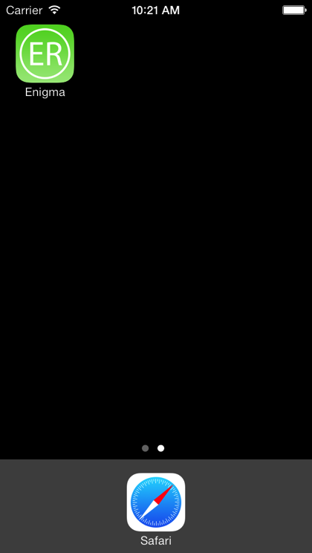  Enigma Remote is started by clicking on the green Enigma app icon. | 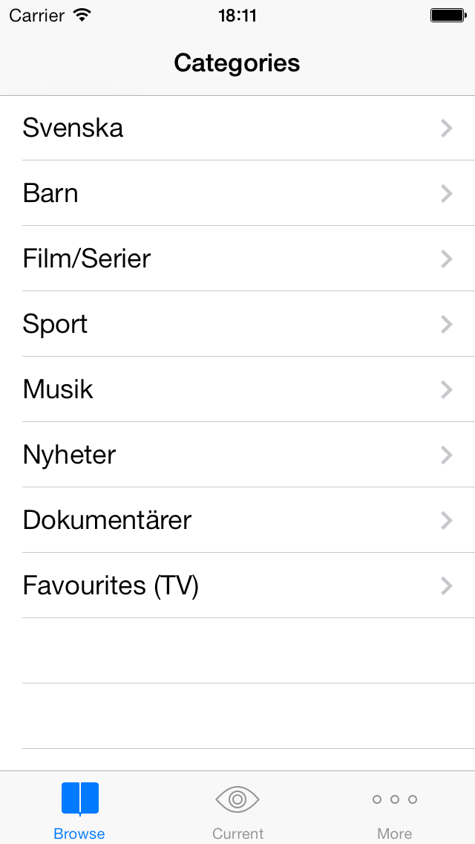  The first view that is presented is the browse categories view. Click on one of the categories to display the channels within that category. If you are running Enigma Remote for the first time this screen will be blank and you need to make a new connection, se below for details on how to do this. Note that since the TV box used for making these screen shots are running swedish language, the categories are in swedish. categories will be in your natural language when running Enigma Remote connected to your own TV box.
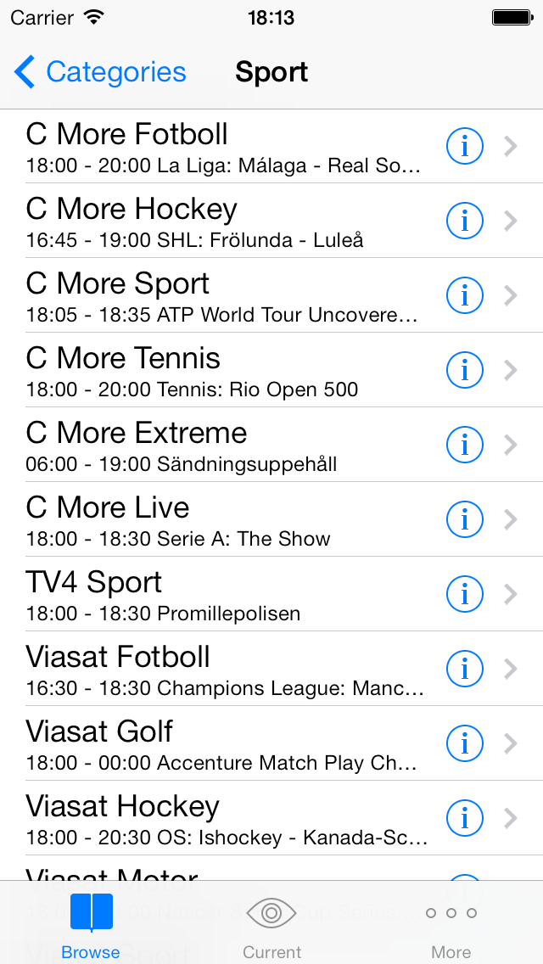  The channels in category Sport, with name and currently running program. To zap to a channel just tap the channel row. To view EPG information for a channel tap the blue indicator button to the right of each channel row. | 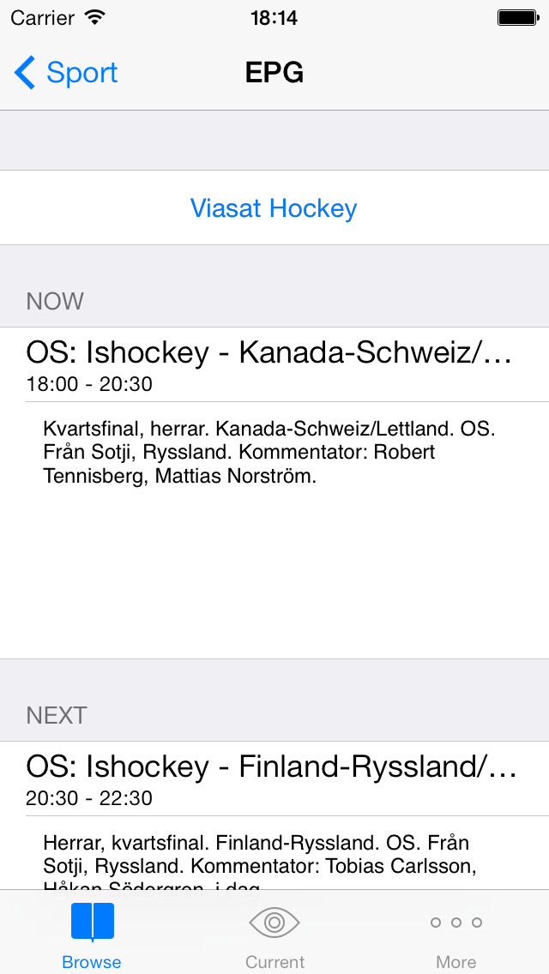  EPG for the channel Viasat Hockey with current and next upcoming program. To zap to this channel immediatelly, tap the blue channel name “Viasat Hockey”. It is possible to display this view for a different channel than the one activelly running on display, i.e. you can watch the EPG of channel A while channel B is the active channel.
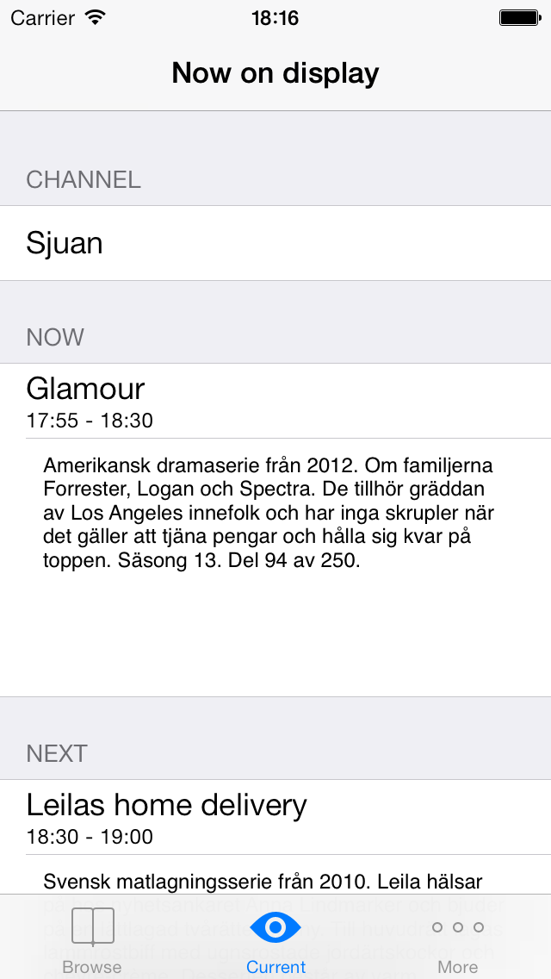  Information about the active channel, i.e. the channels the box is sending to your TV. | 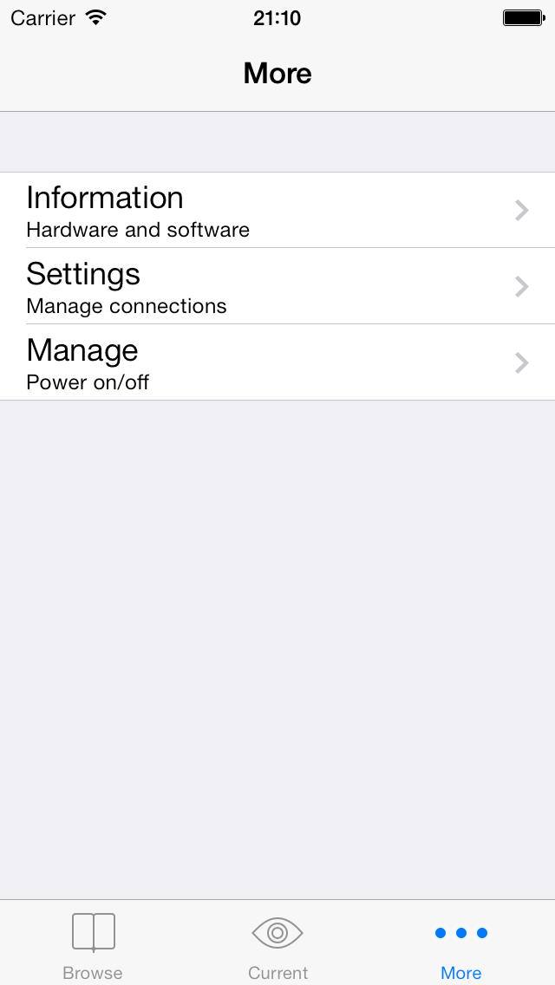  Less frequently used features are located under the More tab.
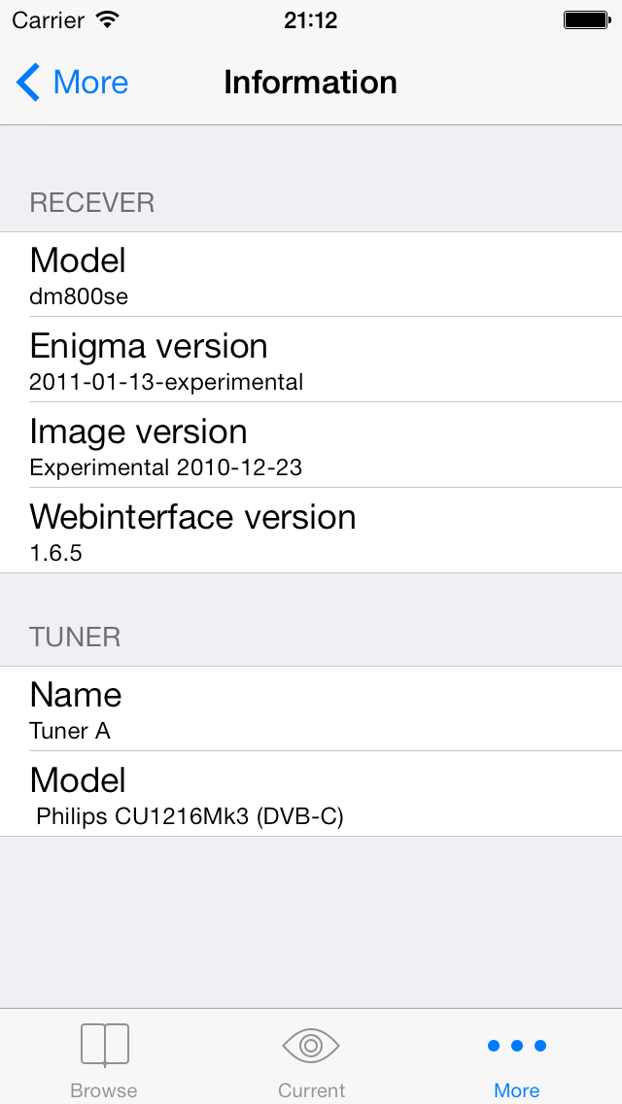  General infromation about the TV-box. Especially the Webinterface versionen is of interest since Enigma Remote is built and verified against version 1.6.5. | 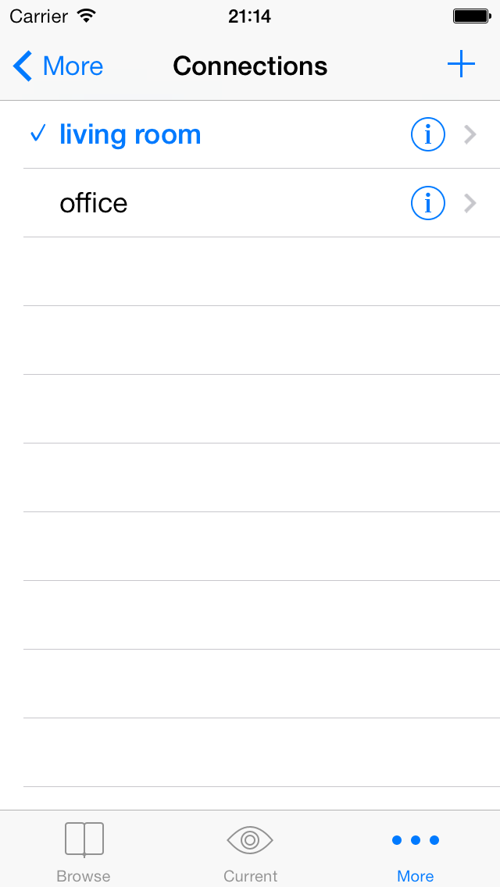  The different TV boxes Enigma Remote has stored connections to. To add a new connection tap the plus sign in the upper right corner.  Enigma Remote is connected to one TV box at a time and the currently active connection is marked by a check box. To change currently active connection tap any other connection.  To see detailed information of a connection tap the blue indicator button to the right of each connection row.
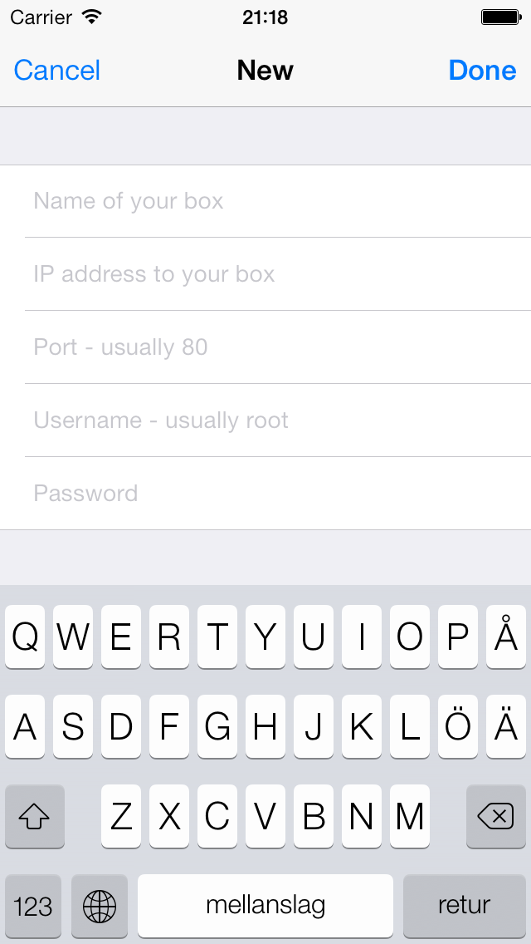  To add a connection to a new TV box, connection informations needs to be added. This is done in the New view. | 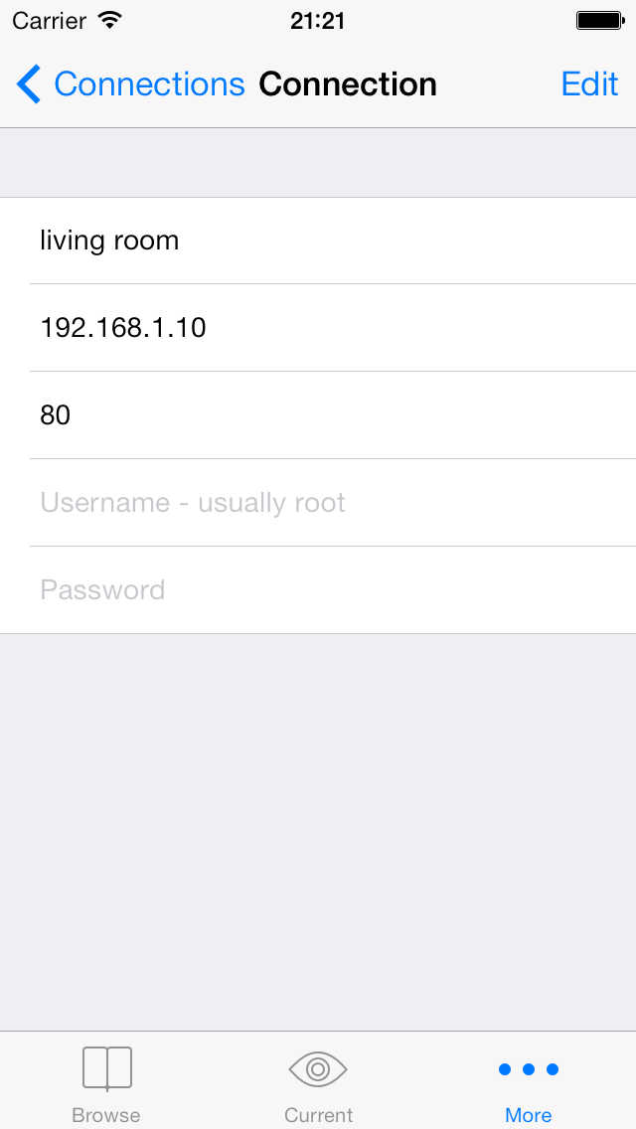  Detailed information for a connection.  To modify the connection tap Edit.
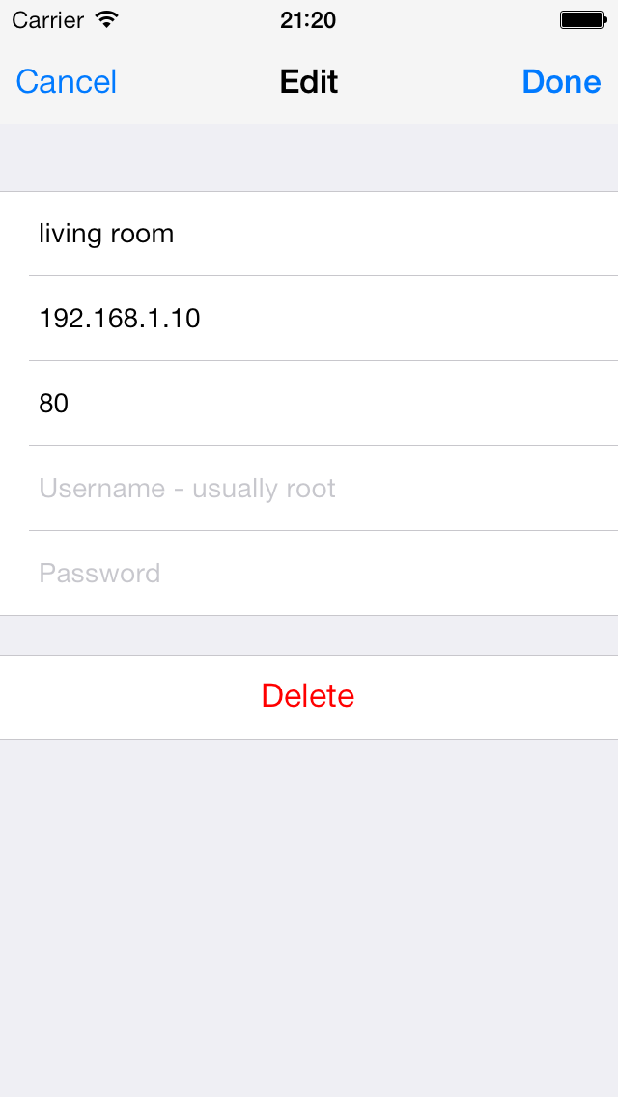  The view where modifications of an existing connection are beeing made. Tap the field that you want to modify and the keyboard will appear. Click on Delete to delete the connection from Enigma Remote. | 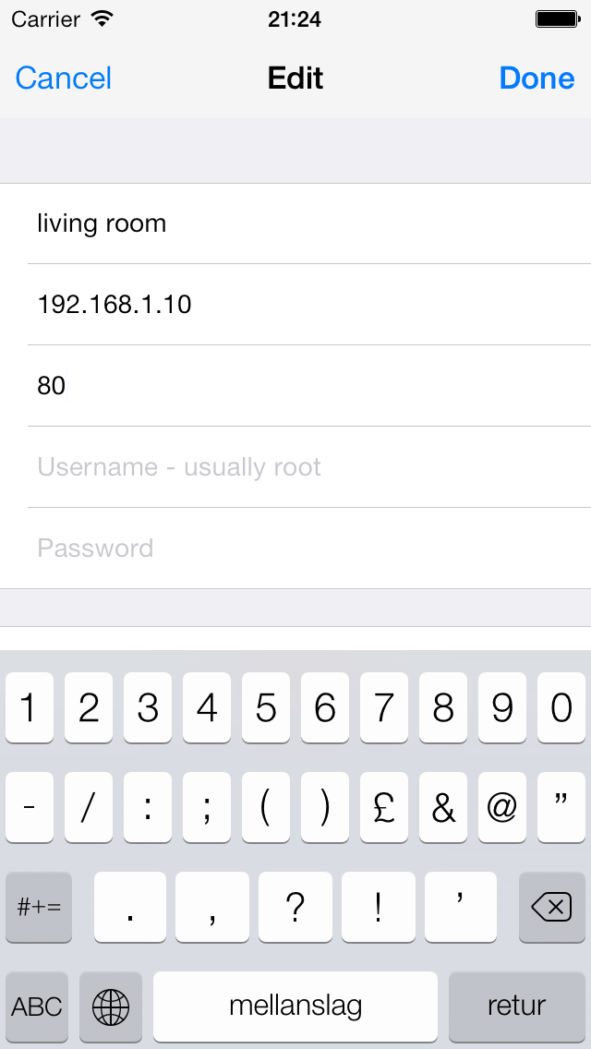  The view to modify an existing connection, here with the keybord displayed. Tap Done to save the changes, cancel to abort.
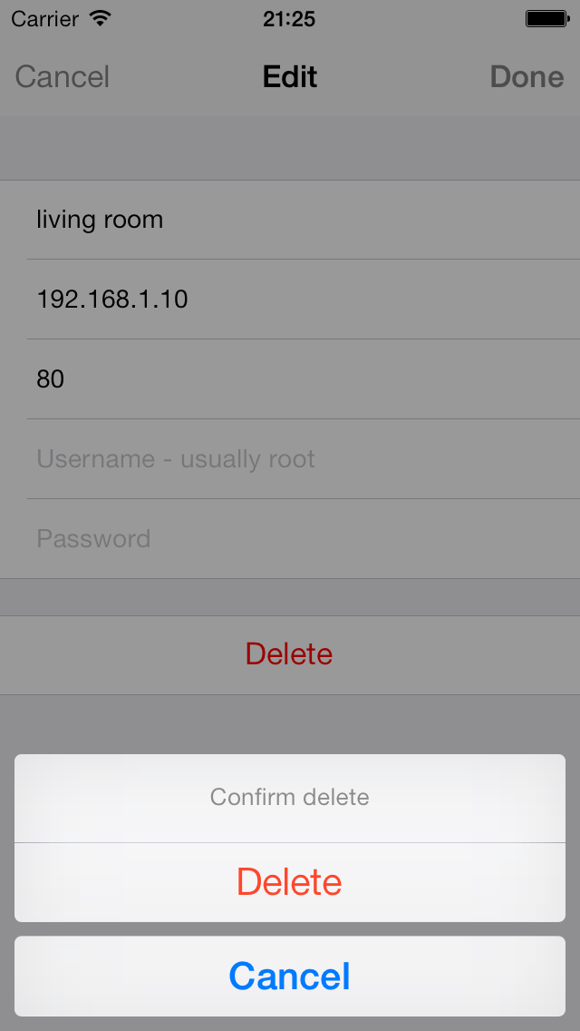  Before deleting a connection a confirmation check is done to prevent unwanted deletions. | 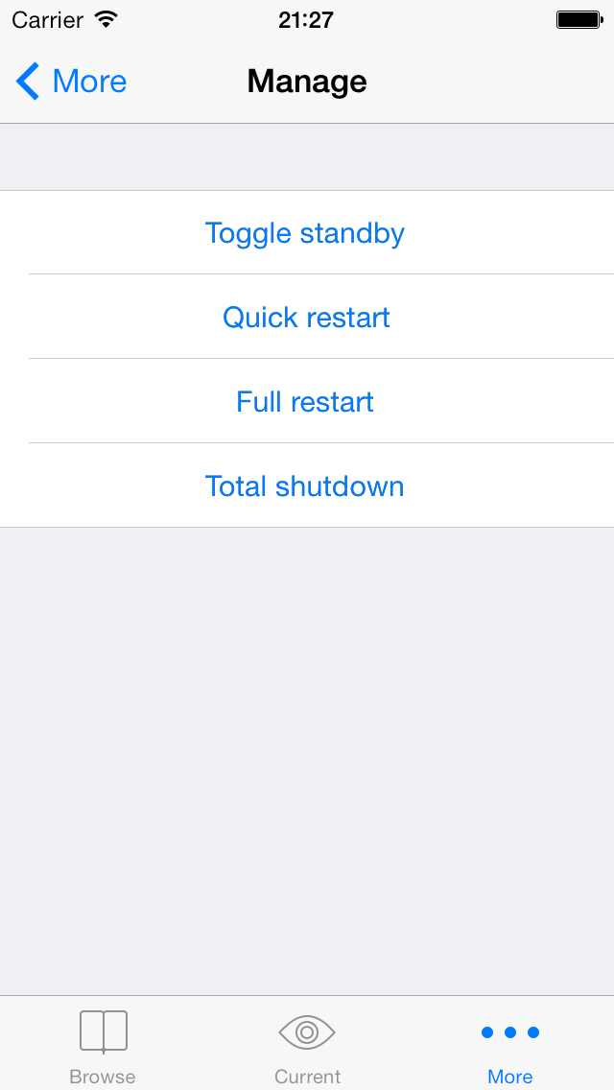  Under Manage the state of the TV box is managed. If the TV box is in standby (power is on but it is not sending any signal to your TV) tap Toggle standby to turn it on.  Quick restart restarts the enigma software in the box.  Full restart reboots the box.  Total shutdown turns the box of completelly.

Can be accessed by entering http://yourbox/web/ in a web browser, where “yourbox“ is replaces by the IP address of the box.

